**Measurement of capacitance**

1. **Schering bridge**

This bridge is used to measure to the [capacitance](https://www.electrical4u.com/what-is-capacitor/) of the capacitor, dissipation factor and measurement of relative permittivity. Let us consider the circuit of **Schering bridge** as shown below

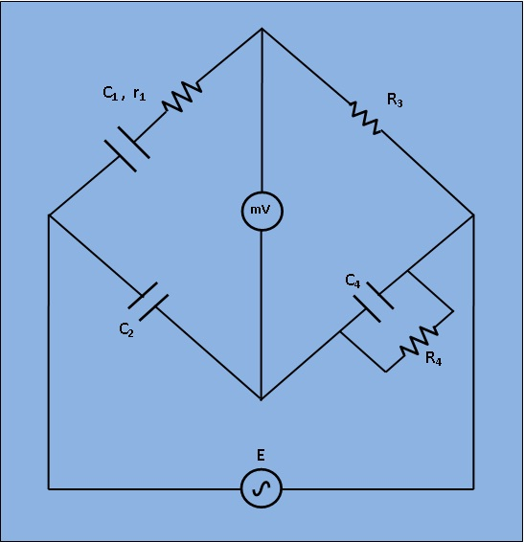

Let, C1=capacitor whose capacitance is to be measured.  
       r1= a series resistance representing the loss in the capacitor C1C1.  
       C2= a standard capacitor.  
       R3= a non inductive resistance.  
       C4= a variable capacitor.  
       R4= a variable non inductive resistance.

At balance condition

Z1 Z4 = Z2 Z3

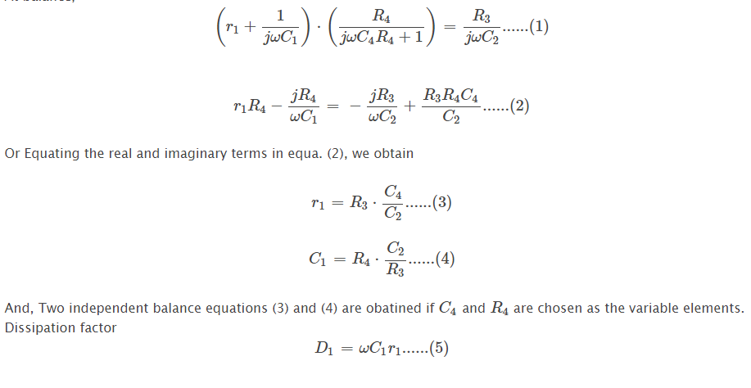

**Measurement of frequency**

1. **Wien bridge**

The circuit consists of four arms, one arm with a series combination of resistor and capacitor and another with a parallel combination resistor and capacitor. The other two arms compress a resistance. The below shows the circuit diagram of Wien's bridge.

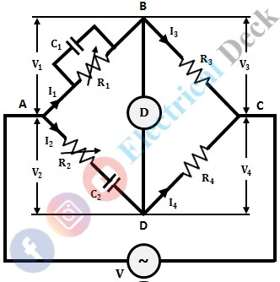

A balance detector or null indicator is connected across two junctions (i.e., across BD as shown above). The indicator shows null deflection when the bridge is balanced i.e. when the junctions B and D will be at the same potential.

**When the bridge is balanced, we have,**

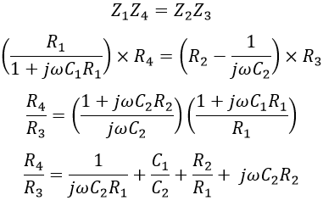

Equating the real terms, we get,

Wien's Bridge

The above equation is used to determine the resistance ratio (R4/R3). Now equating the imaginary terms

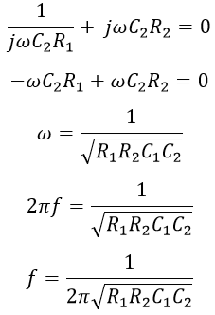

If suppose the bridge components are chosen such that R1 = R2 = R and C1 = C2 = C. Then the above equation is given as,

Wien's Bridge

**Measurement the low-value resistance**

**Kelvin Bridge**

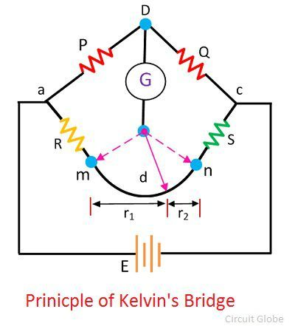

The**r** is the resistance of the contacts that connect the **unknown resistance R** to the **standard resistance S**. The **‘m’** and**‘n’** show the range between which the [galvanometer](https://circuitglobe.com/galvanometer.html) is connected for obtaining a null point.

When the galvanometer is connected to point ‘m’, the lead resistance r is added to the standard resistance S. Thereby the very low indication obtains for unknown resistance R. And if the galvanometer is connected to point n then the r adds to the R, and hence the high value of unknown resistance is obtained. Thus, at point n and m either very high or very low value of unknown resistance is obtained.

So, instead of connecting the galvanometer from point, m and n we chose any intermediate point say d where the resistance of lead r is divided into two equal parts, i.e., r1 and r2

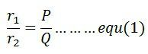

The presence of r1 causes no error in the measurement of unknown resistance.

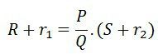

From equation (1), we get

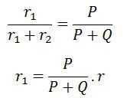

As

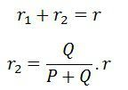

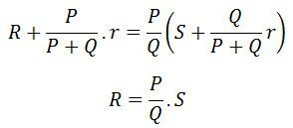

The above equation shows that if the galvanometer connects at point d then the resistance of lead will not affect their results.